UNIVERSITY OF SCIENCES AND TECHNOLOGY OF HANOI
DEPARTMENT OF INFORMATION AND COMMUNICATIONS TECHNOLOGY


BACHELOR THESIS
Trần Anh Đức

ELK BUILT-IN EMAIL PHISHING DETECTION SYSTEM

External Supervisor: Prof. Dr. Trịnh Ngọc Thắng
Internal Supervisor: Prof. Phd. Lê Như Chu Hiệp

To whom it may concern,
I, Trinh Ngoc Thang, certify that the thesis of Mr Tran Anh Duc is qualified to be presented in the Internship October 2024-2025

Hanoi,
Supervisor’s signature

ACKNOWLEDGEMENTS
"I would like to express my gratitude to all those who have facilitated my completion of this thesis, as well as the academic support I received throughout my studies at Hanoi University of Science and Technology.
First of all, I would like to sincerely thank my supervisor, Mr. Trinh Ngoc Thang from CMC Group, and Mr. Le Như Chu Hiep from Hanoi University of Science and Technology for their assistance and support in helping me complete this thesis.
Secondly, I want to thank the university board for providing the conditions for my studies as well as for guiding and developing my future.
I sincerely thank you."

TABLE OF CONTENTS
ABSTRACT 9
TABLE OF CONTENTS 4
LIST OF FIGURES 7
CHAPTER 1: OVERVIEW OF THE TOPIC 10
1.1. Introduction 10
1.1.1. Context and Urgency of Phishing Attack Prevention 10
1.1.2. Challenges in Detecting Sophisticated Attack Forms 10
1.2. Objectives of the Topic 10
1.2.1. General Objective 11
1.2.2. Specific Objectives 11
1.3. Research Subjects and Scope 11
1.3.1. Research Subjects 11
1.3.2. Scope of Research 11
1.4. Research Methodology 12
1.5. Scientific and Practical Significance of the Topic 12
1.6. Structure of the Report 12
CHAPTER 2: THEORETICAL BASIS 13
2.1. Overview of Phishing Attacks 2.1.1. Definition and History 13
2.1.2. Classification of Phishing Attack Forms 13
2.1.3. Common Techniques in a Phishing Email 13
2.2. Methods for Detecting Phishing Emails 14
2.2.1. Traditional Methods (Blacklist/Whitelist, Heuristics) and Limitations 14
2.2.2. Machine Learning-based Methods 14
2.2.3. Approaches Using Large Language Models (LLM) 14
2.3. Introduction of Technologies Used in the Topic 14
2.3.1. Elastic Stack (ELK Stack) 14
2.3.2. Large Language Model 15
2.3.3. ElastAlert Warning Tool 15
2.3.4. Docker and Docker Compose Containerization Platform 15
2.3.5. Telegram Bot Application Programming Interface (API) 16
CHAPTER 3: ANALYSIS AND DESIGN OF THE SYSTEM 17
3.1. Requirement Analysis 17
3.1.1. Functional Requirements 17
3.1.2. Non-functional requirements 18
3.2. Overall system architecture 18
3.3. Detailed Design of Data Processing Flow (Dataflow) 3.3.1. Data Flow Diagram (Sequence Diagram) 19
3.3.2. Detailed Description of Steps in the Processing Flow 20
3.4. Detailed Design of Modules 21
3.4.1. Collection and Classification Module (Python Agent) 21
3.4.2. Log Processing Module (Logstash Pipeline) 22
3.4.3. Data Storage Module (Elasticsearch Indexing) 22
3.4.4. Visualization Module (Kibana Dashboard) 22
3.4.5. Alert Module (ElastAlert Rules và Telegram Alerter) 23
CHAPTER 4: DEPLOYMENT AND EVALUATION OF RESULTS 24
4.1. Deployment Environment 24
4.2. Detailed Installation and Configuration Guide 24
4.2.1. Docker Compose Configuration 24
4.2.2. Filebeat Configuration (filebeat.yml) 25
4.2.3. Logstash Pipeline Configuration (pipeline.conf) 25
4.2.4. ElastAlert Configuration (config.yaml và phish_rule.yaml) 25
4.3. Test Scenatio and Experimental Results 26
4.4. Evaluation of results 41
4.4.1. The results achieved compared to the set goals 41
4.4.2. Analysis of the system’s advantages 42
4.4.3. Analysis of disadvantages and existing limitations 42
CHAPTER 5: CONCLUSION AND DEVELOPMENT DIRECTIONS 43
5.1. Conclusion 43
5.2. Development directions of the project 43
Refernce List 45

LIST OF FIGURES
Figure 1: Overall architecture diagram of the system 17
Figure 2: Sequence diagram of data processing flow 18
Figure 3: Operational status of the containers 24
Figure 4: When Python Agent analyzes email 24
Figure 5: When Python filter the necessary fields 25
Figure 6: When Python Agent analyzes the sender's IP 26
Figure 7: When Python Agent analyzes the sender's IP 27
Figure 8: When Python Agent analyzes email 28
Figure 9: When Python Agent analyzes email 28
Figure 10: Event processing log of Logstash 29
Figure 11: Filebeat config 30
Figure 12: Running log 31
Figure 13: Index management interface in Kibana, showing that index phish-mail-* has been successfully created. 31
Figure 14: Detailed table of email events on the Dashboard. 31
Figure 15: Data Views management interface in Kibana with phish-mail-* filter 32
Figure 16: Details of the Index Pattern configuration phish-mail-* in Kibana 32
Figure 17: Details of data fields in the Data View phish-mail-* on Kibana. 33
Figure 18: Overall Phishing Overview Dashboard interface 34
Figure 19: Pie chart classifying emails by LLM 35
Figure 20: Event trend chart over time 35
Figure 21: Risk level statistics 35
Figure 22: Statistics of the number of emails containing URLs in the blacklist 36
Figure 23: Table of statistics of the most frequently appearing URLs (Top URLs) on the Dashboard 36
Figure 24: Detailed data table of email events on the Kibana Dashboard 36
Figure 25: Phishing email alerts sent via Telegram. 37

ABSTRACT
Email phishing attacks are one of the most serious and common cybersecurity threats today, causing significant financial and data losses for individuals and organizations. Recognizing the urgency of the issue, this topic focuses on researching, designing, and implementing an automated and intelligent system for monitoring, detecting, and alerting phishing emails.
The solution is built on a combination of the open-source big data analytics platform Elastic Stack (ELK) and the power of Large Language Models (LLM). Specifically, the system performs a closed-loop processing procedure: (1) Collecting emails and using the LLM API (for example, Gemini) to analyze semantics and classify; (2) Using Filebeat and Logstash to collect, enrich, and normalize data; (3) Storing and indexing data on Elasticsearch for high-speed querying; (4) Visualizing data through dashboards on Kibana to provide an overview for analysts; and (5) Using ElastAlert to automatically send real-time alerts to administrators via Telegram when a high-risk email is detected [10].
The entire system is deployed on the Docker platform, ensuring flexibility, ease of management, and scalability. Experimental results show that the system operates effectively, accurately detecting phishing emails and providing timely alerts. The topic not only provides a highly applicable technological solution but also contributes to demonstrating the enormous potential of integrating artificial intelligence into modern cybersecurity defense systems.

CHAPTER 1: OVERVIEW OF THE TOPIC

1.1. Introduction

1.1.1. Context and Urgency of Phishing Attack Prevention
In the digital age, email has become an indispensable means of communication and information exchange for both individuals and organizations. However, this popularity has also made email one of the most favored channels for cyber attacks by hackers. Among the threats, phishing attacks have emerged as a persistent, sophisticated form of attack that causes the most severe damage. Phishing attacks not only aim to steal sensitive personal information such as bank accounts and passwords but also serve as a stepping stone for more dangerous attacks like ransomware or distributed denial-of-service (DDoS) attacks.
The damage caused by phishing is not limited to financial losses but also severely impacts the reputation of businesses and the data safety of users. In light of the continuous development of attack techniques, building a proactive defense system capable of detecting and early warning of phishing emails is an urgent requirement for all organizations.

1.1.2. Challenges in Detecting Sophisticated Attack Forms
Traditional phishing detection methods, such as using blacklists of harmful domains or IP addresses, or filtering emails based on fixed rules and keywords, are increasingly proving ineffective. Attackers continuously change their tactics, employing sophisticated evasion techniques such as:
- Using new domains that have never appeared on blacklists.
- Concealing harmful URLs with link shortening services.
- Exploiting psychological and social factors (social engineering) to create emails with content and context identical to legitimate emails.
These challenges require a new, smarter approach that can "understand" the semantics and underlying intentions behind the email content, rather than relying solely on surface indicators.

1.2. Objectives of the Topic
In response to those requirements and challenges, this topic is implemented to achieve the following objectives:

1.2.1. General Objective
To build a complete system capable of monitoring, detecting, analyzing, and automatically warning about emails with signs of fraud in real-time, thereby enhancing the cybersecurity defense capabilities for an organization or system.

1.2.2. Specific Objectives
To achieve the general objective, the topic will carry out the following specific tasks:
- Research centralized log data processing and analysis technologies, especially the Elastic Stack toolkit (Elasticsearch, Logstash, Kibana, Filebeat).
- Design and build a complete data processing pipeline, from collection, enrichment, storage to visualization.
- Integrate Large Language Model (LLM) through API to classify emails, leveraging natural language analysis capabilities to detect sophisticated threats [6].
- Build an automatic alert mechanism, sending instant notifications to administrators via the Telegram application when detecting high-risk emails.
- Deploy the entire system on a containerized platform (Docker) to ensure flexibility, manageability, and deployment ease.
- Test and evaluate the effectiveness of the system through simulation scenarios.

1.3. Research Subjects and Scope

1.3.1. Research Subjects
Research subjects: The components of an email (headers, body, hyperlinks URLs) and the attributes enriched during processing (IP address, sender domain, geographic location...).

1.3.2. Scope of Research
Scope of research: The topic focuses on building a phishing email detection system based on content analysis. The main technologies used include Elastic Stack, Python, ElastAlert, Telegram API, and Docker. The topic does not delve into analyzing attachments containing malware.

1.4. Research Methodology
The topic uses an experimental research method, including the following steps:
- Theoretical research: Understanding an overview of phishing attacks and related technologies.
- Analysis and design: Based on theoretical foundations, proceed to design the architecture and detailed workflow for the system.
- Practical implementation: Install, configure, and integrate technology components according to the design.
- Testing and evaluation: Use sample data to operate the system, record results, evaluate effectiveness, and identify advantages and disadvantages.

1.5. Scientific and Practical Significance of the Topic
- Scientific significance: The topic proposes a solution that combines big data analysis platforms (ELK Stack) and artificial intelligence (LLM), demonstrating the potential of applying AI to practical cybersecurity problems [3].
- Practical significance: The built system has high applicability, can be deployed in enterprises and organizations to automate the monitoring and response processes to email threats, helping to minimize risks and save human resources.

1.6. Structure of the Report
In addition to the introduction, the report is structured into the following main chapters:
- Chapter 2: Theoretical Basis. Presenting the foundational knowledge about phishing attacks and the technologies used in the topic.
- Chapter 3: System Analysis and Design. Describing in detail the architecture, data flow, and design of each component in the system.
- Chapter 4: Implementation and Evaluation of Results. Presenting the installation process, configuration, experimental results, and providing evaluations of the system.
- Chapter 5: Conclusion and Development Directions. Summarizing the results achieved and proposing research directions and improvements for the future.

CHAPTER 2: THEORETICAL BASIS
This chapter presents the foundational knowledge and theoretical basis related to the topic, including an overview of phishing attacks, detection methods, and a detailed introduction to the technologies chosen to build the system.

2.1. Overview of Phishing Attacks
2.1.1. Definition and History
Phishing is a form of cyber attack in which the attacker impersonates a reputable entity or individual to deceive users into revealing sensitive information such as usernames, passwords, credit card information, or to perform other harmful actions. The term "phishing" originated in the 1990s, stemming from the hacker community using deceptive techniques (fishing for information) to hijack America Online (AOL) accounts.

2.1.2. Classification of Phishing Attack Forms
- Email Phishing: This is the most common form, in which the attacker sends a large number of spoofed emails to a vast number of users.
- Spear Phishing: A more sophisticated form of attack, targeting a specific individual or group of people. The attacker often gathers information about the victim to create a highly personalized email, increasing the likelihood of success.
- Whaling: A type of Spear Phishing, but the targets are high-level individuals in an organization such as CEOs or CFOs.
- Smishing: Using text messages to trick users into clicking on malicious links.
- Vishing: Using phone calls to carry out fraudulent activities.

2.1.3. Common Techniques in a Phishing Email
- Email Spoofing: Altering information in the email header to make the recipient believe the email is from a trustworthy source.
- Creating Malicious URLs: Using techniques such as URL shortening, employing similar characters (homograph attack), or embedding malicious URLs into seemingly valid links.
- Social Engineering Techniques: Exploiting human psychology by creating a sense of urgency ("Your account will be locked in 24 hours"), fear, or curiosity to prompt users to act without thinking carefully.

2.2. Methods for Detecting Phishing Emails

2.2.1. Traditional Methods (Blacklist/Whitelist, Heuristics) and Limitations
- Blacklist/Whitelist: This is the simplest method, based on maintaining a list of IP addresses, domain names, or email addresses that have been identified as harmful (blacklist) or safe (whitelist). The biggest limitation of this method is that it cannot detect new threats (zero-day attacks) that are not on the list.
- Heuristic Analysis and Rule-based: Building a set of rules to evaluate emails, for example: checking for mismatches between the display name and the real email address, detecting commonly used keywords in phishing emails ("verify account," "urgent"). This method is rigid and easily bypassed by attackers by changing the content.

2.2.2. Machine Learning-based Methods
Machine Learning algorithms such as Naive Bayes, Support Vector Machines (SVM), and Random Forest are used to build classification models. The input data consists of features extracted from emails such as the number of links, the presence of JavaScript, the age of the domain, etc. This method is more flexible than rule-based but requires a complex feature extraction process and may struggle with new forms of attacks [3].

2.2.3. Approaches Using Large Language Models (LLM)
This is the most advanced method currently available. LLMs like GPT and Gemini have the ability to deeply understand the context, meaning, and nuances of natural language. By analyzing the entire content of the email, LLMs can identify sophisticated phishing elements that other methods may miss, such as creating a false sense of urgency or unreasonable requests.

2.3. Introduction of Technologies Used in the Topic

2.3.1. Elastic Stack (ELK Stack)
ELK is a powerful trio of open-source products from Elastic, designed to collect, process, and analyze logs and events.
- Elasticsearch: Is the heart of the ELK Stack. This is a distributed search and analytics engine built on Apache Lucene. It stores data in the form of JSON documents and allows for complex queries to be executed at near real-time speed [12].
- Logstash: Is the component responsible for server-side data processing. It has the ability to collect data from various sources, perform transformations (parse, enrich, filter), and then send the data to a storage location (stash), in this case, Elasticsearch.
- Kibana: Is the data visualization tool. It provides a web interface that allows users to explore, create charts, tables, and dashboards to monitor and analyze data stored in Elasticsearch.
- Filebeat: Is a lightweight "agent" installed at the log source. Its task is to monitor log files, collect events, and forward them to Logstash or directly to Elasticsearch.

2.3.2. Large Language Model
Gemini is one of the most advanced large language models developed by Google. It has the ability to process multimodal data, understand, and generate text with high complexity. In the scope of the topic, the Gemini API is used as an intelligent classification service [6]. By sending email content to the API, the system receives classification results (phishing or legit) along with reliability, significantly enhancing the accuracy of detection [2].

2.3.3. ElastAlert Warning Tool
ElastAlert is an open-source framework developed by Yelp, used to create alerts from data in Elasticsearch. It works by periodically querying Elasticsearch and matching data with predefined rules. When a rule is satisfied (for example: detecting an email with risk_level: high), ElastAlert will trigger one or more alert actions, such as sending an email, sending a message via Slack, or calling a webhook.

2.3.4. Docker and Docker Compose Containerization Platform
- Docker: Is a platform that allows packaging an application and all its dependencies into a standardized unit called a "container." Containers ensure that the application runs consistently across all environments.
- Docker Compose: Is a tool that allows defining and running multi-container Docker applications. By using a YAML file (docker-compose.yml), users can configure all the services of the application (in this topic, Elasticsearch, Logstash, Kibana, Filebeat, ElastAlert...) and launch them with a single command.

2.3.5. Telegram Bot Application Programming Interface (API)
Telegram provides a powerful Bot platform along with a simple HTTP API set. It allows developers to create applications that can interact with Telegram users. In this topic, this API is used to create an instant alert channel: when ElastAlert detects a threat, it will call the Telegram Bot API to send a detailed message about that phishing email to a chat channel or a predefined administrator user.

CHAPTER 3: ANALYSIS AND DESIGN OF THE SYSTEM
This chapter focuses on analyzing the requirements of the system, thereby providing an overall architectural design and detailed design for each component. The goal is to build an effective, flexible, and scalable email phishing detection system.

3.1. Requirement Analysis

3.1.1. Functional Requirements
The system needs to perform the following core functions:
- Collect email: Automatically retrieve emails form designated sources (sample data or real sources).
- Extract information: Extract important components from emails such as header, body, and hyperlinks (URLs).
- Classify using AI: Send the email content to a Large Language Model (LLM) for classification and labeling (phishing or legit) along with confidence.
- Event logging: Create and record each analyzed email event as a structured JSON document.
- Log transport: Automatically collect and push event log files to the central processing system.
- Data processing and enrichment: Perform ETL (Extract, Transform, Load) tasks such as data normalization, extracting additional information (IP, sender domain), data enrichment (GeoIP geographic information), and calculating risk level (risk_level).
- Data storage: Safely and efficiently store processed events in a database with strong search and analysis capabilities.
- Data lifecycle management: Automatically manage storage, such as deleting old data after a certain period to optimize space.
- Visualization and analysis: Provide a visual dashboard interface for users (security analysts) to monitor, search, filter, and analyze data.
- Automatic alerts: Continuously monitor data and automatically send alerts through an instant channel (Telegram) when high-risk events are detected.

3.1.2. Non-functional requirements
- Performance: The system must be capable of processing and alerting in near real-time to ensure timely responses.
- Scalability: The architecture must allow for easy scaling as the volume of incoming emails increases, by adding new processing nodes without disrupting the system.
- Reliability: The system must operate stably and continuously 24/7, minimizing downtime.
- Usability: The monitoring dashboard interface must be user-friendly and intuitive, helping analysts easily grasp the situation and investigate incidents.
- Security: Ensure the safety of data and communication channels, especially sensitive information such as API keys for calling LLM services.

3.2. Overall system architecture
To meet the above requirements, the project proposes a distributed system architecture based on open-source components and cloud services, described in Figure 1. 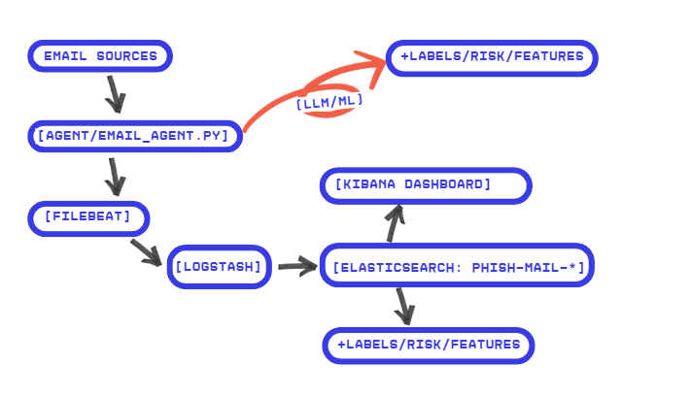
Figure 1: Overall Architecture Diagram of the System
The architecture includes the following main blocks:
- Ingestion Layer:
  - Python Agent (email_agent.py): Input component, responsible for fetching emails, calling the LLM API (e.g., Gemini) to analyze and generate event log files.
  - Filebeat: Acts as a log shipper, collecting logs generated by the Agent and sending them to the Processing Layer.
- Processing Layer:
  - Logstash: The center of the data processing pipeline, performing ETL tasks to normalize and enrich log data.
- Storage Layer:
  - Elasticsearch: NoSQL database, storing all processed events for search and analysis purposes.
- Observation & Alerting Layer:
  - Kibana: Web interface to visualize data from Elasticsearch through dashboards.
  - ElastAlert: Background service, continuously querying Elasticsearch to detect threats and trigger alerts.
- External Services:
  - Gemini API: AI service called to perform email classification.
  - Telegram API: Service called to send alert notifications.
All components of the system (except for API services) are packaged and managed by Docker and Docker Compose, forming a uniform and isolated deployment environment.

3.3. Detailed Design of Data Processing Flow (Dataflow)
3.3.1. Data Flow Diagram (Sequence Diagram)
The data flow in the system is designed to operate automatically and sequentially. Below is a detailed description of the steps in the processing flow, which can be illustrated by a sequence diagram (Sequence Diagram)
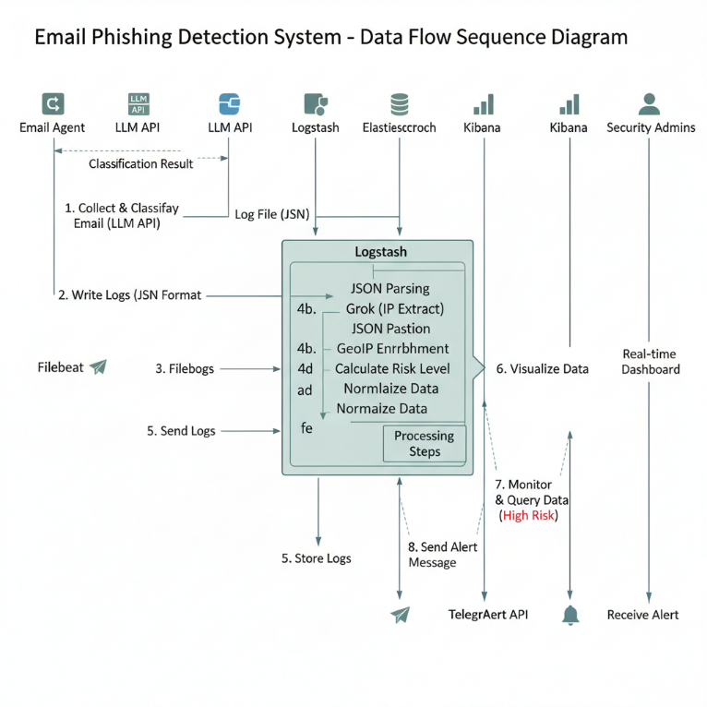
Figure 2: Sequence Diagram of Data Processing Flow

3.3.2. Detailed Description of Steps in the Processing Flow
- Step 1: Collection and Classification: email_agent.py retrieves a new email. It extracts the necessary information (headers, body, URLs) and creates a prompt to send to the Gemini API.
- Step 2: Logging: After receiving the classification results (llm_label, llm_confidence) from Gemini, the Agent combines this information and logs it as a complete event in JSON format into a log file.
- Step 3: Log Transport: Filebeat is monitoring this log file, as soon as it detects a new log line, it will immediately read and send it to Logstash via port 5045.
- Step 4: Log Processing (ETL): Logstash receives data from Filebeat. Logstash's pipeline applies a series of filters to:
  - Analyze the JSON string.
  - Use Grok to extract the sender's IP address.
  - Enrich GeoIP data from the IP address.
  - Calculate risk_level based on llm_label and llm_confidence.
  - Normalize data fields.
- Step 5: Storage: Logstash exports the processed document into an index in Elasticsearch. The index name is set by date (phish-mailYYYY.MM.dd) for easier management.
- Step 6: Visualization: The new data in Elasticsearch can immediately be queried and displayed on the Kibana dashboard.
- Step 7: Monitoring and Alerts: At the same time, ElastAlert periodically (e.g., every minute) runs a query to Elasticsearch to find new events that meet the defined rules (e.g., risk_level: "high").
- Step 8: Send Notification: If ElastAlert's query finds matching results, it will trigger an alert action, format a message containing important information (sender, subject, risk level), and call the Telegram API to send this message to the admin team's chat channel.

3.4. Detailed Design of Modules

3.4.1. Collection and Classification Module (Python Agent)
- Function: Retrieve email, call LLM, log.
- Design: A Python script using libraries such as imaplib to retrieve email, requests or Google's client library to call the Gemini API.
- Output JSON Log Structure:
json
{
"timestamp": "...",
"sender": "...",
"recipient": "...",
"subject": "...",
"body": "...",
"urls": ["..."],
"llm_label": "phishing",
"llm_confidence": 0.98
}

3.4.2. Log Processing Module (Logstash Pipeline)
- Input: Configure to receive data from Filebeat on port 5045.
- Filter: The following filter plugins are applied:
  - json {}: To parse the JSON log string from the Agent.
  - grok {}: To extract the IP address from the header.
  - geoip {}: To use the extracted IP field to enrich with geolocation information.
  - mutate {}: To transform data types, rename or remove unnecessary fields.
  - if [llm_label] == "phishing" {}: Conditional logic to calculate risk_level.
- Output: Configure to export data into Elasticsearch with daily index roration.

3.4.3. Data Storage Module (Elasticsearch Indexing)
- Index Template (index-template.json): A predefined template that automatically applies mappings (schema) to newly created phish-mail-*indices. This ensures consistency in data types across fields.
- ILM Policy (ilm-policy.json): A lifecycle management policy for indices designed to automate tasks such as moving an index from hot storage to cold storage after a period of time, or automatically deleting indices after a long retention period (e.g/ 90 days) to free up storage

3.4.4. Visualization Module (Kibana Dashboard)
- Data View: Create a data view with pattern phish-mail-* for Kibana to identify the indexes to work with.
- Dashboard "Phishing Overview": Built from saved visualizations, including:
  - Pie chart for llm_label.
  - Area chart for event trends over time.
  - Data table for Top 5 sending domains, Top 5 dangerous URLs.
  - Metric for total number of high-risk alerts.
  - Detailed event table (Discover saved search).

3.4.5. Alert Module (ElastAlert Rules và Telegram Alerter)
- Rule design:
  - name: Name of the rule, for example: Phishing Email with High Risk.
  - type: any (trigger for each matching event).
  - index: phish-mail-*.
  - filter: An Elasticsearch Query DSL query to find documents matching the conditions, for example: {"term": {"risk_level.keyword": "high"}}.
  - alert: Specify the action to be taken, which is telegram.
  - alert_text: Format template for the alert message, can insert fields from the document like "{0} From: {1}, Subject: {2}".
  - telegram_bot_token and telegram_room: Parameters to connect and send messages to the correct bot and chat channel.

CHAPTER 4: DEPLOYMENT AND EVALUATION OF RESULTS
This chapter presents in detail the environment, installation steps, and configuration to deploy the phishing email detection system. At the same time, the chapter also presents the experimental results obtained through testing scenarios and provides objective assessments of the system's operational effectiveness.

4.1. Deployment Environment
The system is deployed in an environment using the following technologies:
- Operating System: Ubuntu 22.04 LTS.
- Containerization Platform: Docker Engine version 20.10.x or higher, Docker Compose version 1.29.x or higher.
- Component Versions:
  - Elastic Stack: Version 8.x (including Elasticsearch, Logstash, Kibana, Filebeat).
  - Python: Version 3.9 or higher.
  - ElastAlert: Version compatible with Elasticsearch 8.x.0

4.2. Detailed Installation and Configuration Guide
The system is deployed through Docker Compose, which simplifies the management of containers. Below are the main configuration steps for each component.

4.2.1. Docker Compose Configuration
The docker-compose.yml file defines all the services of the system, including Elasticsearch, Logstash, Kibana, Filebeat, and ElastAlert. This file sets parameters such as the image to be used, the ports exposed to the outside, the volumes to map configuration files from the host to the container, and the network setup for the containers to communicate with each other.

4.2.2. Filebeat Configuration (filebeat.yml)
Filebeat is configured to read data from JSON log files generated by the Python Agent.
- Input: Specify the path to the log file (e.g., /var/log/email_events/*.json).
- Output: Configuration to send the collected data to the Logstash service at address logstash:5045.

4.2.3. Logstash Pipeline Configuration (pipeline.conf)
This is the most important configuration file, defining the ETL processing flow.
- Input: Listening on port 5045 to receive data from Filebeat.
- Filter: Applying a series of filters to analyze and enrich the data, including json, grok, geoip, and mutate.
- Output: Pushing the processed data into Elasticsearch.

4.2.4. ElastAlert Configuration (config.yaml và phish_rule.yaml)
The alert rules are defined in this file.
- es_host, es_port: Specify the connection information to Elasticsearch.
- name, type, index: Define the name, type of rule, and index to be monitored (phish-mail*).
- filter: Set the conditions to trigger the alert, for example, finding emails with risk_level as high.
- alert: Specify the alert action, in this case, telegram.
- alert_text: Format the content of the message to be sent.

4.3. Test Scenatio and Experimental Results
To test and demonstrate the operation of the system, a test scenario was conducted by inputting a sample phishing email into the system. The results were recorded at each stage as follows:
- Launching the system: All components of the system were launched using the command docker-compose up. (Figure 3) shows that all containers (Elasticsearch, Kibana, Logstash, Agent...) are in an active state.
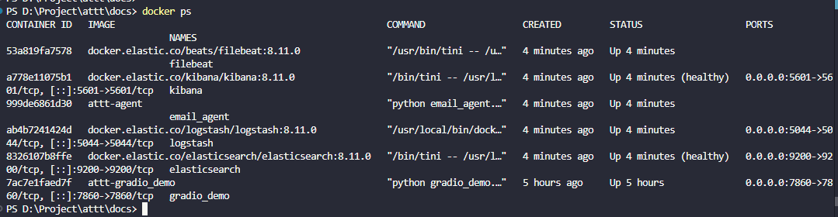
Figure 3: The operational status of the containers
- Data processed through Logstash: When the Python Agent analyzes the email and writes to the log file, Filebeat will collect and push it to Logstash. The log of Logstash (Figure 10) shows that it has successfully received and processed events, applying filters such as geoip to enrich the data.
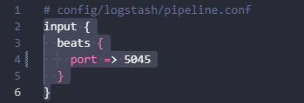

Figure 4: When the Python Agent analyzes the email

The configuration snippet sets up Logstash to listen to the Beats protocol on port 5045 to receive logs from Filebeat. This is the first "ingest" step in the processing layer, ensuring that JSON email events are reliably transferred from the collector (Filebeat) into Logstash's pipeline in a push-based manner. Using the Beats protocol helps transmit data efficiently, has backpressure and acknowledgment mechanisms, and clearly separates the collection component from the processing component in the ELK architecture.
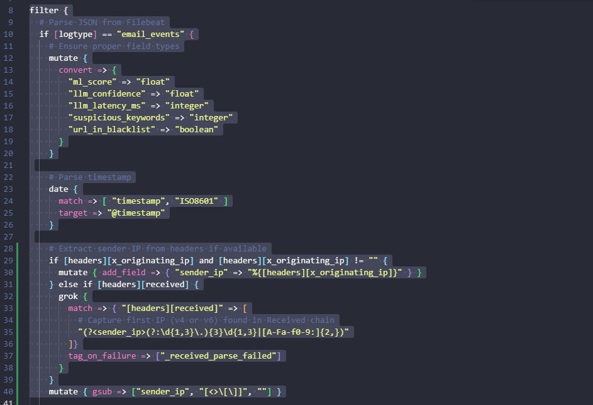
Figure 5: When Python filters the necessary fields
The configuration snippet shows three main processing groups in the Logstash pipeline:
- Data type normalization: forcing fields such as ml_score, llm_confidence, llm_latency_ms, suspicious_keywords, url_in_blacklist to the correct numeric/boolean type to preserve comparison and querying.
- Time normalization: mapping timestamp (ISO8601) to @timestamp to synchronize the event time reference for Elasticsearch/Kibana.
- Source extraction: prioritizing headers.x_originating_ip; if not available, using grok to extract the IP address (IPv4/IPv6) from the headers.received string, then cleaning the value.
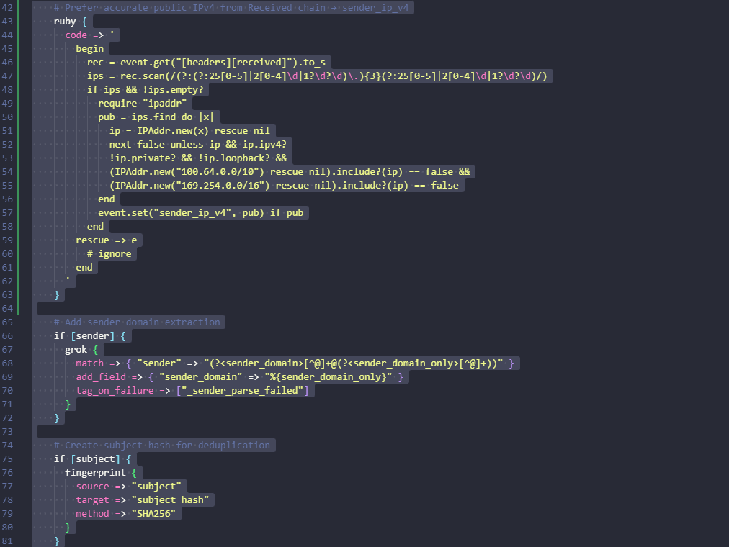
Figure 6: When the Python Agent analyzes the sender’s IP
- Public IPv4 filtering: The Ruby block scans the headers.received string to find all IPv4, removes private/loopback/link-local ranges, selects the first public IP, and assigns it to sender_ip_v4. Purpose: to use the "real" IP for accurate analysis and GeoIP lookup.
- Extracting sender_domain: Grok separates the domain part from the sender field, normalizes it into sender_domain for statistics, grouping, and alerting rules by sender domain.
- Hashing subject: Fingerprint creates subject_hash using SHA256 to eliminate duplicates and group emails with similar subjects during analysis/alerting.
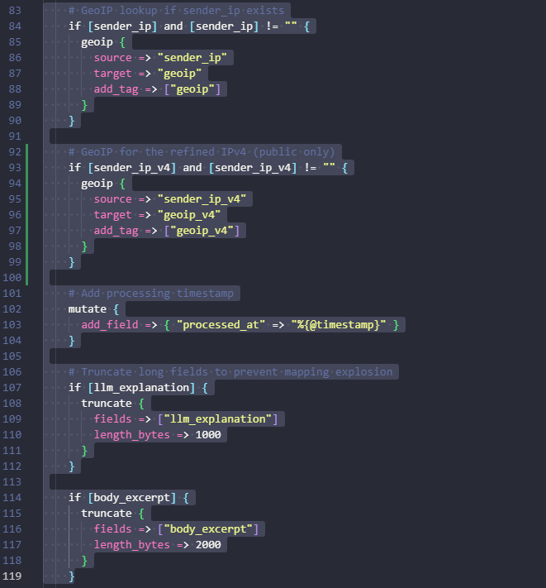
Figure 7: When the Python Agent analyzes the sender’s IP
- GeoIP: Look up the geographical location for sender_ip and the filtered version sender_ip_v4, stored in geoip/geoip_v4 for analyzing the source of dissemination by country/city.
- Processing timestamp: Add processed_at = @timestamp to distinguish between the event creation time and the time the pipeline processes.
- Length limit of fields: Trim llm_explanation (≤ 1000 bytes) and body_excerpt (≤ 2000 bytes) to avoid "mapping explosion," optimize storage and querying.
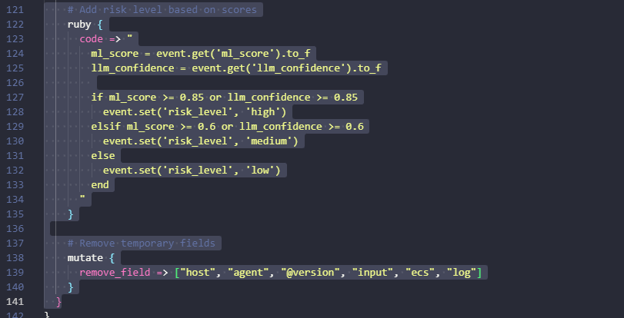
Figure 8: When the Python Agent analyzes email
- Risk classification: The ruby block assigns risk_level based on score thresholds:
  - high if ml_score ≥ 0.85 or llm_confidence ≥ 0.85
  - medium if ml_score ≥ 0.6 or llm_confidence ≥ 0.6
  - low for the remaining cases
- Streamline events: mutate.remove_field removes temporary fields (host, agent, @version, input, ecs, log) to reduce document size and avoid noise when querying/displaying.
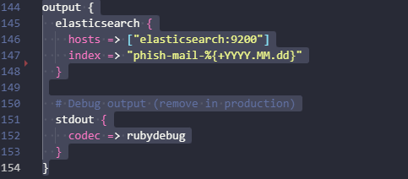
Figure 9: When the Python Agent analyzes email
- Elasticsearch Output: Send events to elasticsearch:9200, index by date phishmail-%{+YYYY.MM.dd} to help manage, rotate, and optimize queries over time.
- Diagnosis (temporary): stdout { codec => rubydebug } in detailed log output to console for testing the pipeline; should be turned off in production environment to save resources.
Log:
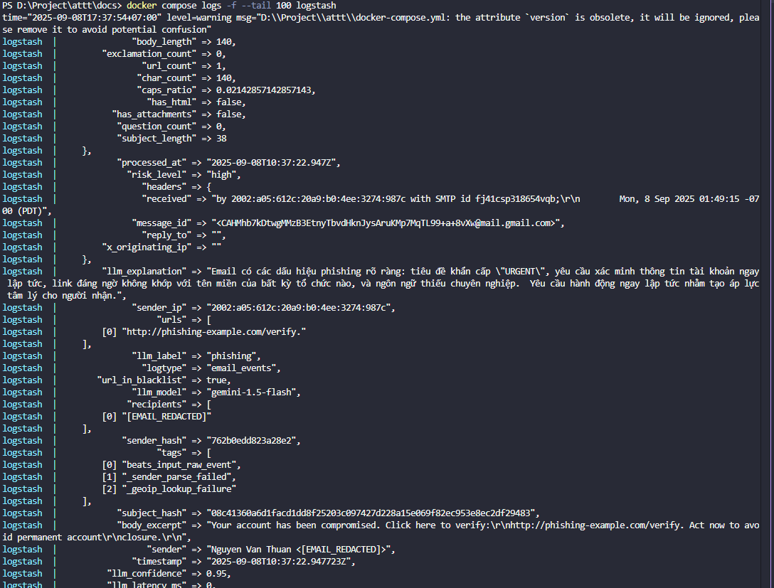
Figure 10: Log processing events of Logstash
The image shows a document event after passing through the Logstash pipeline: the fields have been normalized and enriched such as llm_label, llm_confidence, ml_model, suspicious_keywords, url_in_blacklist, sender, sender_hash, urls, features. on Elasticsearch.
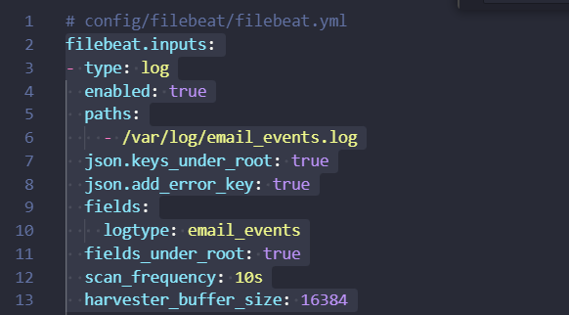
- Input source: type: log, monitor file /var/log/email_events.log.
- JSON decoding: json.keys_under_root: true brings JSON fields to root; json.add_error_key: true records parse errors.
- Labeling: add fields.logtype: email_events for Logstash to correctly identify the pipeline.
- Frequency/performance: scan the file every 10s (scan_frequency) and set harvester_buffer_size to 16384 bytes for stable collection.

Hình 11: Filebeat config
This configuration requires Filebeat to monitor the file /var/log/email_events.log, decode the logs in JSON format directly into root, label logtype: email_events for proper routing at Logstash, and set a scan interval of 10 seconds to ensure new events are forwarded promptly into the processing pipeline.
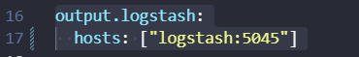
Hình 12: Log running
The declaration output.logstash.hosts: routes all events from Filebeat to Logstash through port 5045 on the internal Docker network. This setup separates collection and processing, allowing Logstash to perform parsing/enrichment before indexing into Elasticsearch.
- Data written to Elasticsearch: After processing, Logstash pushes the data into Elasticsearch. On the Kibana interface, in the Index Management section, it can be seen that the index phish-mail-* has been created and the number of documents is increasing, indicating that the data is being successfully written (Figure 13).
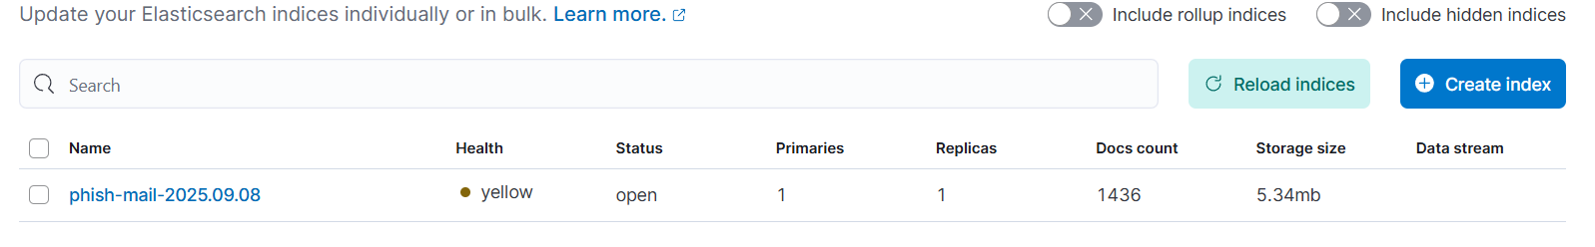
Figure 13: Index management interface in Kibana, showing that the index phish-mail-*has been successfully created
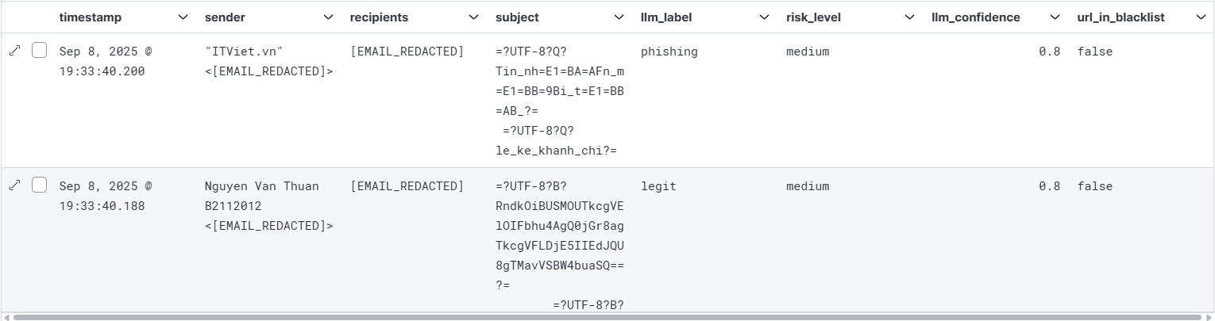
Figure 14: Detailed table of email events on the Dashboard
The Discover interface displays emails indexed into phish-mail-* with the main fields: time (timestamp), sender (sender), recipients (recipients), subject (subject), AI label (llm_label), risk level (risk_level), confidence (llm_confidence), and URL blacklist flag. Illustration of two records: one labeled "phishing" by LLM, one "legit", both with risk_level = medium according to the scoring threshold in the pipeline.
- Analysis and Visualization on Kibana: Discover: Data can be explored in detail in the Discover section. Figure 15 illustrates filtering emails labeled as phishing by LLM and viewing the details of a document, with all enriched fields.
Kibana → Stack Management → Data Views: `phish-mail-*`.
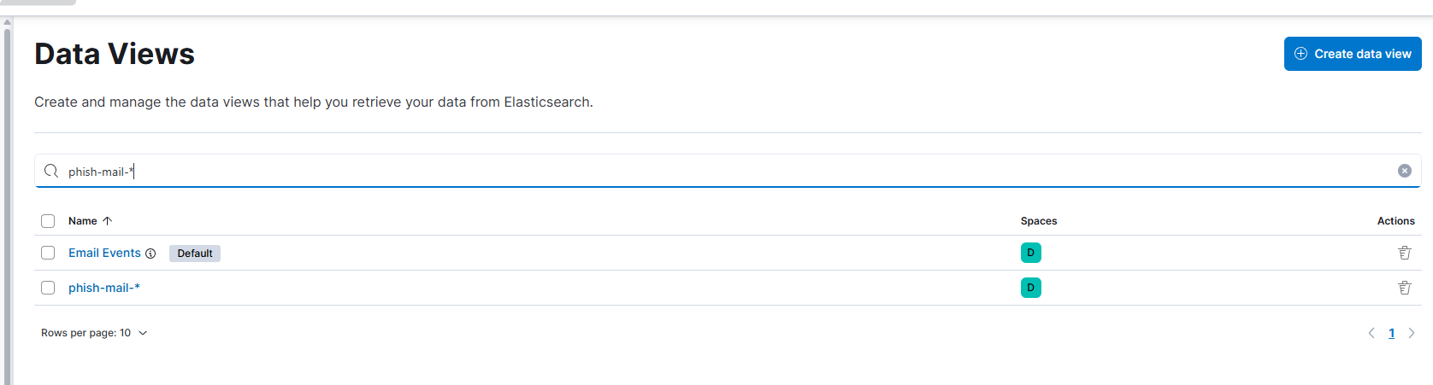
Figure 15: Data Views management interface in Kibana with phish-mail-*filter
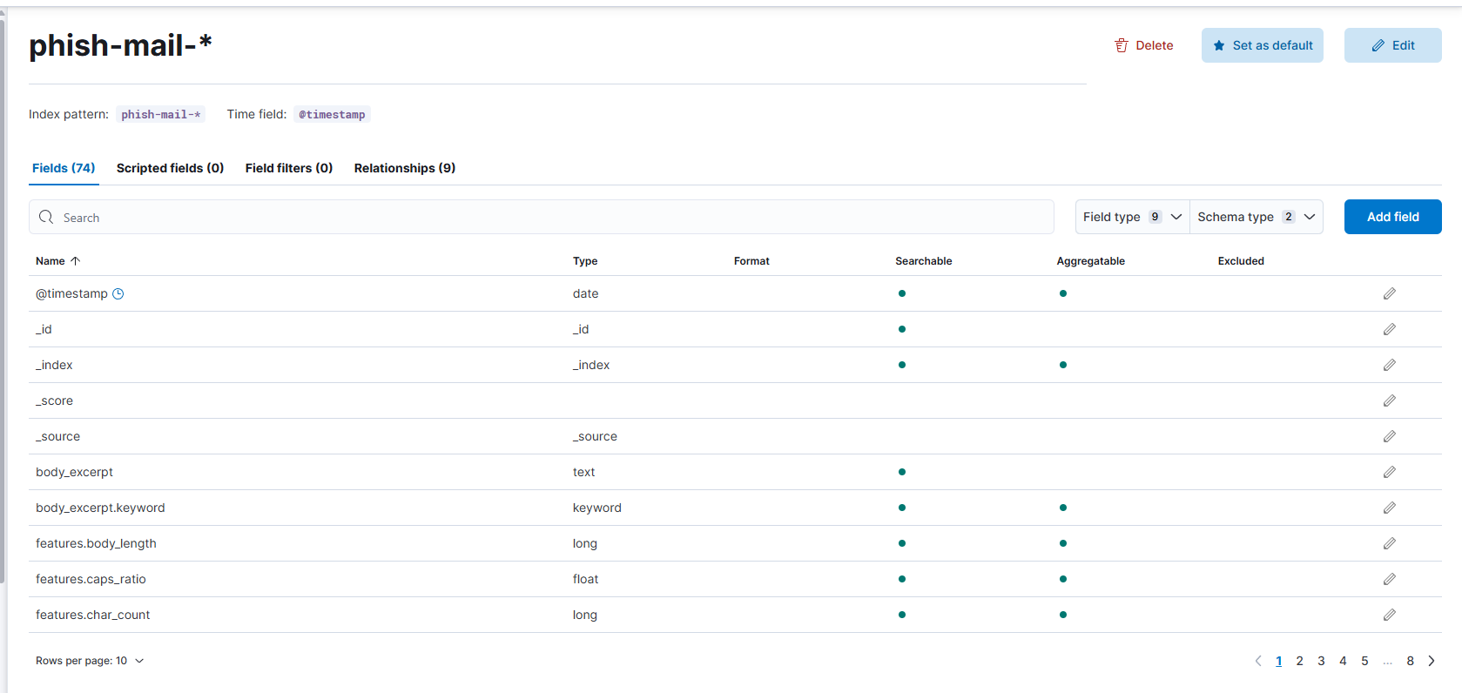
Figure 16: Detailed configuration of Index Pattern phish-mail-*in Kibana
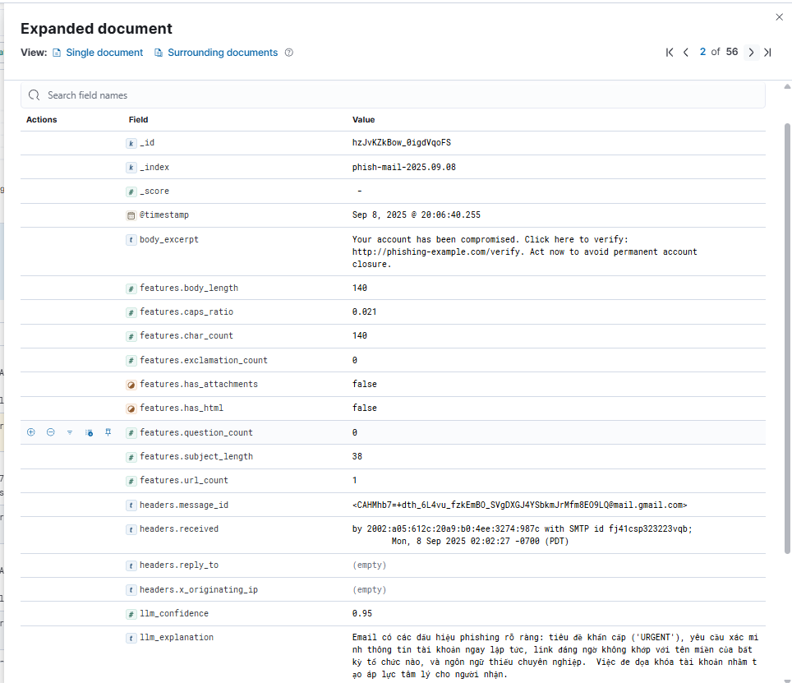
Figure 17: Details of the data fields in Data View phish-mail-*on KIbana

Dashboard "Phishing Overview": All data is compiled and visualized on the main dashboard of the system (Figure 18).
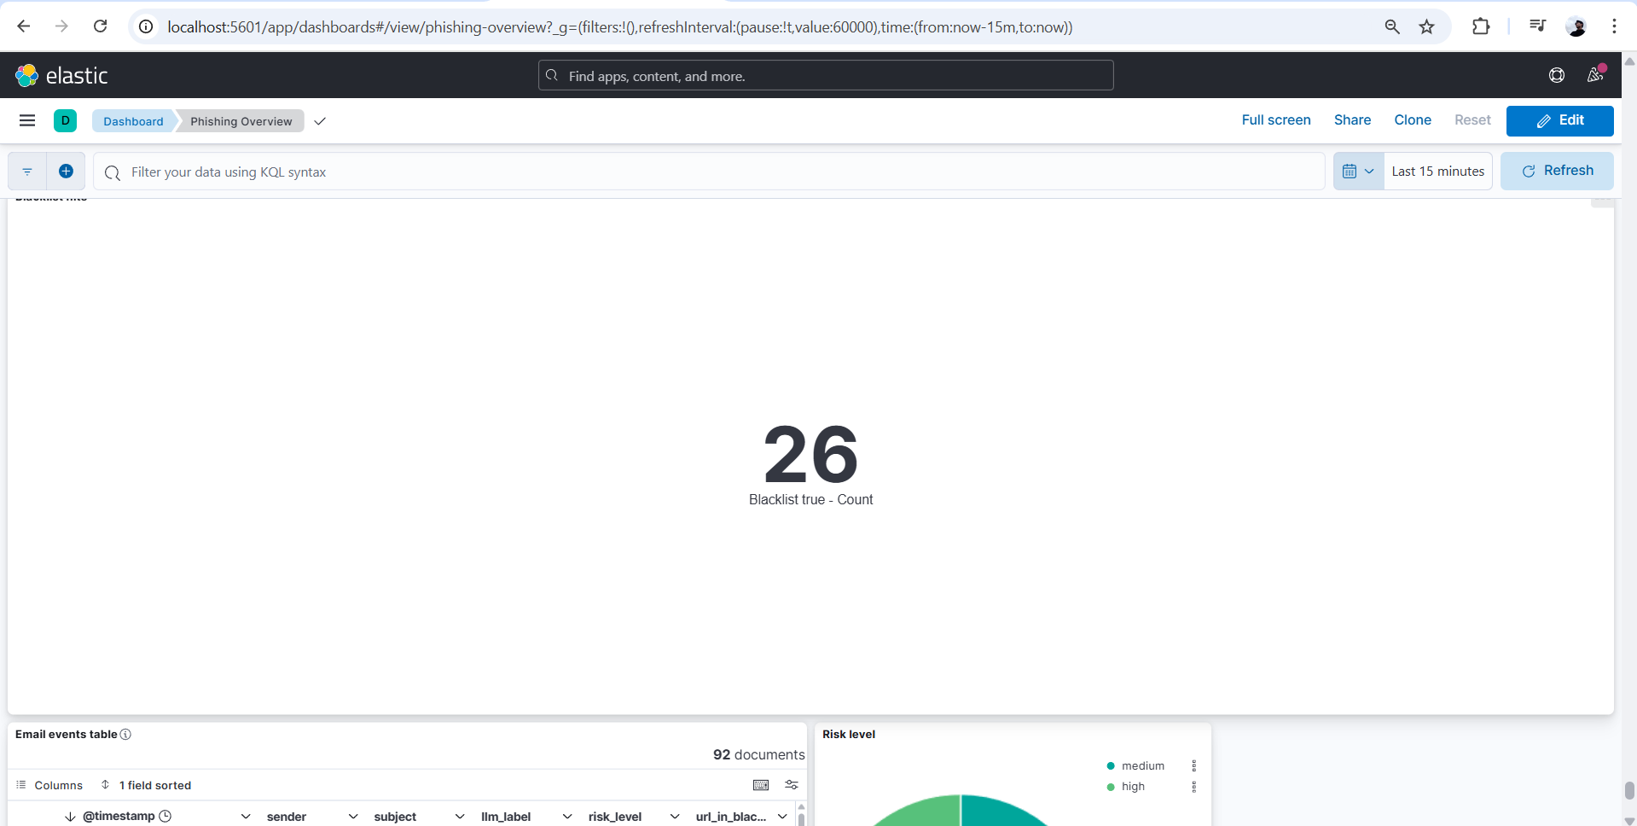
Figure 18: Overall Phishing Overview Dashboard interface
This dashboard provides a comprehensive view through detailed charts:
- The rate of phishing and valid emails (Figure 19).
- Trends of attacks over time (Figure 20).
- Distribution of emails by risk level (Figure 21).
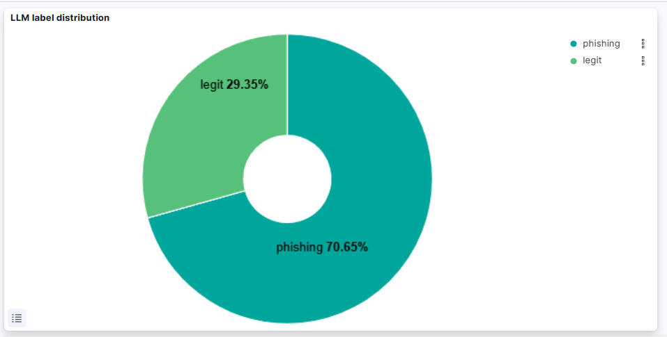
Figure 19: Pie chart classifying emails by LLM

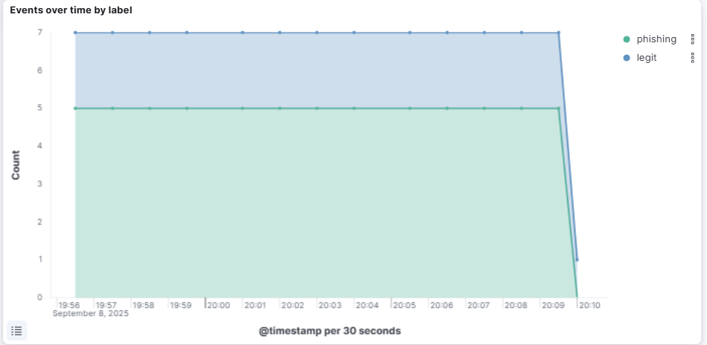
Figure 20: Event trend chart over time
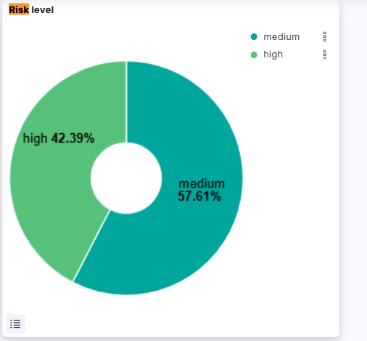
Figure 21: Risk level statistics

Figure 22: Statistics of the number of emails containing URLs in the blacklist
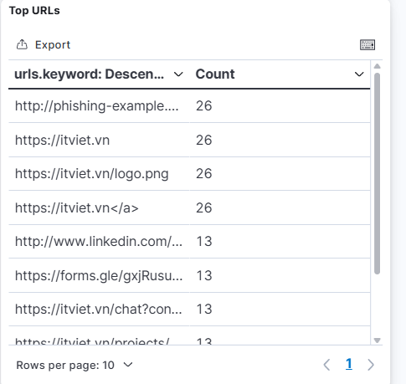
Figure 23: Table of statistics of the most frequently appearing URLs on the Dashboard
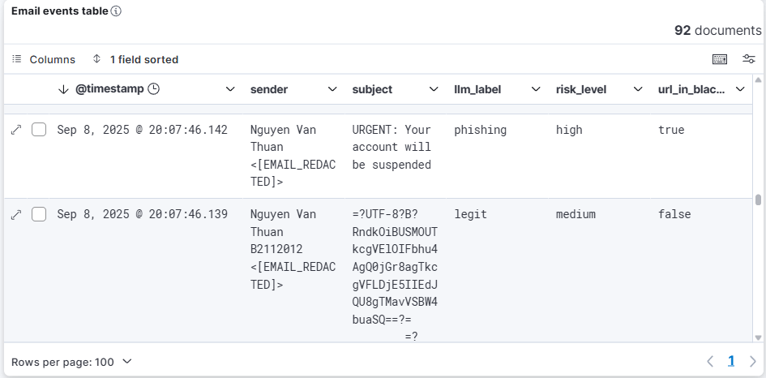
Figure 24: Detailed data table of email events on the Kibana Dashboard
- Activate and send alerts: When an email is identified with a risk_level of high, the rules in ElastAlert will be activated. Immediately, a detailed notification containing important information about the phishing email will be sent to the Telegram channel of the administration team (Figure 25).
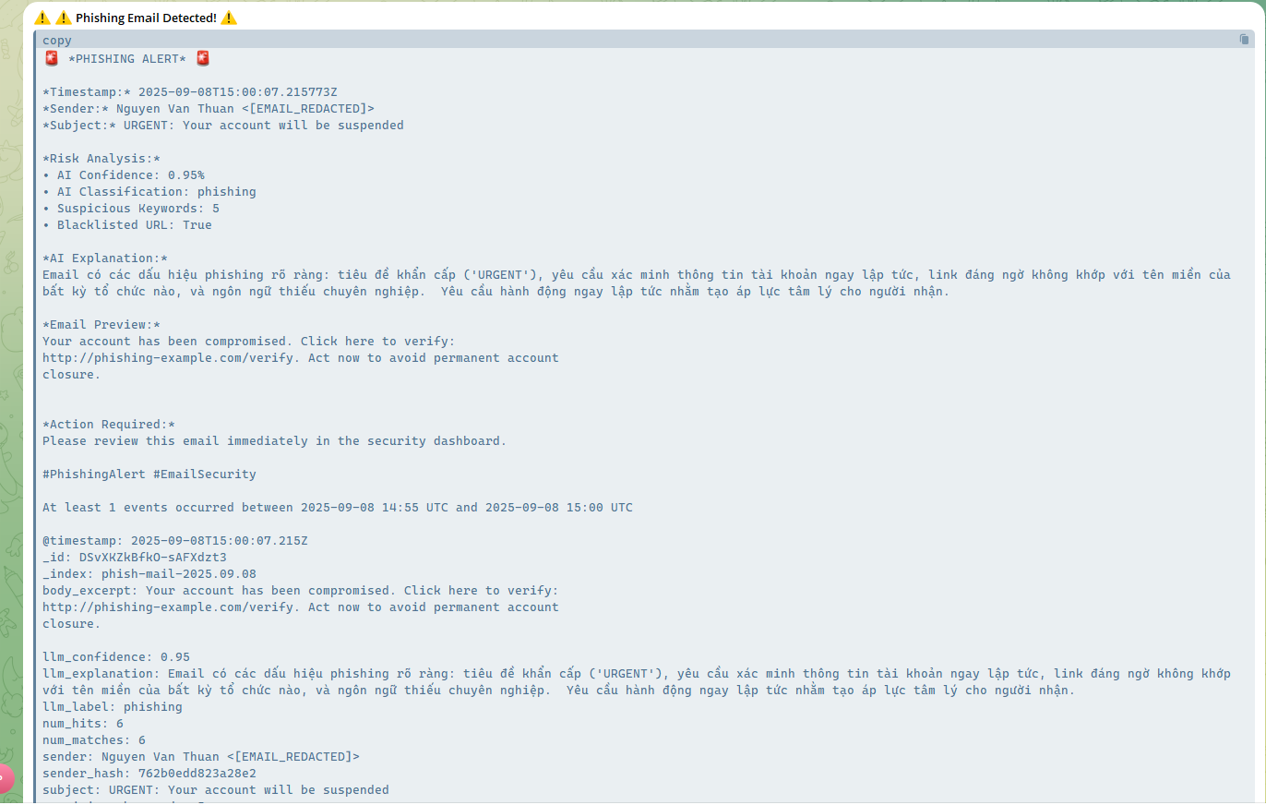
Figure 25: Phishing email alert sent via Telegram
The experimental process has demonstrated that the system operates as designed, with the data flow moving smoothly from the collection stage to the alert sending stage, providing an effective automated monitoring and response solution.

4.4. Evaluation of results
Based on the implementation process and experimental results, the topic presents some evaluations of the system as follows:

4.4.1. The results achieved compared to the set goals
- The system has successfully built a complete log data processing pipeline.
- Successfully integrated Large Language Model to enhance detection capabilities compared to traditional methods.
- Provided a visual monitoring interface, helping analysts easily track and investigate.
- Built an automatic alert mechanism, quickly through popular communication channels (Telegram), helping to shorten response time to threats.

4.4.2. Analysis of the system’s advantages
- High automation: The entire process from analysis to alerting is automated, minimizing human intervention.
- Intelligent detection: The use of LLM helps detect sophisticated phishing emails, based on context rather than just relying on keywords or signatures.
- Good scalability: The architecture based on ELK Stack and Docker allows for easy scaling when email traffic increases.
- Cost-effective: The system is primarily built on open-source technologies, helping to save on licensing costs.

4.4.3. Analysis of disadvantages and existing limitations
- Dependence on external services: The system relies on the stability and policies of API services (Gemini, Telegram). Any changes from the provider can affect operations.
- Latency: Although close to real-time, there is still a certain delay in the processing, from the moment the email is received to when the alert is sent out.
- Possibility of false results (False Positives/Negatives): Although LLM is very powerful, no model is perfect. The system still has the potential for misclassification, requiring continuous monitoring and fine-tuning from humans.
- Maintenance: A regular maintenance plan is needed for components, especially updating rules in Logstash and ElastAlert to cope with new attack forms.

CHAPTER 5: CONCLUSION AND DEVELOPMENT DIRECTIONS

5.1. Conclusion
Through the research and implementation process, the project has achieved the core goal of successfully building a complete simulation system to automatically detect, analyze, and warn about phishing emails. The system has demonstrated its effectiveness and practicality in addressing this urgent cybersecurity issue. The main results achieved include:
- Successfully building an end-to-end data processing pipeline: The system has established a seamless data processing flow, from the initial email collection, enriching and analyzing data using Logstash, to efficient storage and querying on Elasticsearch, and finally visualizing on Kibana.
- Successfully integrating artificial intelligence (AI): By incorporating a Large Language Model (LLM) into the analysis process, the system has significantly enhanced the ability to detect sophisticated phishing attacks, which is a weakness of traditional rule-based methods.
- Establishing a real-time alert mechanism: The system has successfully implemented an automatic alert mechanism via ElastAlert and Telegram, helping to minimize the time from threat detection to notification to the management team, facilitating timely response and incident handling.
- Ensuring flexibility and scalability: Deploying the entire system on the Docker platform not only simplifies the installation process but also ensures portability, consistency, and easy scalability in the future.

5.2. Development directions of the project
Although the system has met the initial objectives, there is still much potential for improvement and expansion in the future. Below are some development directions that can be considered:
- Enhancing detection capabilities:
  - Analyzing attachments: Integrating a Sandbox environment (such as Cuckoo Sandbox) to automatically analyze attachments in emails, detecting malware.
  - Optimizing Prompts for LLM: Research and experiment with different prompts (commands) to improve the accuracy of the LLM model, while also expanding the ability to recognize other types of attacks such as Business Email Compromise (BEC).
  - Integrating Multi-Source Threat Intelligence: Supplement additional data sources on threats (threat intelligence feeds) from the community to enrich and cross-reference information, not just limited to blacklists.
- Developing Automated Response Capabilities (SOAR):
Upgrade the system from merely alerting to automated response. For example: automatically trigger scripts to:
    - Block the IP/domain of the sender on the firewall.
    - Disable malicious URLs found in emails at the network gateway.
    - Automatically isolate suspicious emails from the user's inbox.
- Expanding Monitoring Scope:
  - Apply similar models to analyze and detect threats on other communication channels such as SMS messages (Smishing), messages on social media platforms, etc.
- Building Feedback Loop Mechanism:
  - Develop an interface that allows analysts to mark alert results as true (True Positive) or false (False Positive). This feedback data can be used to refine rules in ElastAlert or even to fine-tune the AI model to make the system increasingly intelligent.

Refernce List
[1] Đỗ Xuân Chọ và Nguyễn Đình Hóa, "Phát hiện Email URL lừa đảo sử dụng học máy có giám sát," Tạp chí Khoa học Đại học Mở Hà Nội, số 78, tr. 1-11, 2022.
[2] Trần Huỳnh Tiến, "Ứng dụng Representation Learning phát hiện website lừa đảo," Luận văn Thạc sĩ, Ngành Kỹ thuật An toàn thông tin, Học viện Công nghệ Bưu chính Viễn thông, Hà Nội, 2020.
[3] Nhóm tác giả, "Nghiên cứu xây dựng giải pháp thu thập và quản lý log sự cố an ninh mạng sử dụng ELK Stack," Báo cáo Đồ án môn học, Ngành An toàn thông tin, Trường Đại học Công nghệ Thông tin, 2020.
[4] Nhóm tác giả, "Nghiên cứu công cụ ELK Stack trong hoạt động giám sát và phát hiện bất thường," Báo cáo Đề tài nghiên cứu khoa học, Học viện Kỹ thuật Quân sự, Hà Nội, 2022.
[5] Trung tâm VNCERT/CC, "Cảnh báo về các chiến dịch tấn công lừa đảo sử dụng trí tuệ nhân tạo (AI)," Cổng thông tin điện tử Cục An toàn thông tin, Bộ Thông tin và Truyền thông, 2024.

